**Professional Practice**

**Team Contract**

Team Name: Undecided

Date: Friday 21st February 2020

|  |
| --- |
| GOALS: What are our team goals for this project?  What do we want to accomplish? What skills do we want to develop or refine? |
| * To improve our project management skills. * Communication and collaboration skills. * Leadership skills, all undertaking the role of SCRUM master. * Advance knowledge of certain business problems. * Learn and improve game design skills using Python. |
| EXPECTATIONS: What do we expect of one another in regard to attendance at meetings, participation, frequency of communication, the quality of work, etc.? |
| * To meet every Monday morning to discuss and work on the project. (Monitored via attendance log) * To meet on agreed Fridays to conduct a SCRUM meeting, evaluate where we are and to work on the project. (Monitored via attendance log) * Keep in communication via the Discord & Trello. (Providing screenshots) * Let the team know if you cannot make a session. * Every team member should provide their own contribution towards the project and supply at least 30% of the workload to sufficient standards. * Each team member will avoid plagiarism. |
| POLICIES & PROCEDURES: What rules can we agree on to help us meet our goals and expectations? |
| * Source code should always be pushed and submitted through the git repository highlighted in the document named “Git Project Link.docx”. * All other documentation and contracts should be supplied to the [Google Drive f](https://drive.google.com/drive/u/0/folders/1n_-k1hK93eRMj_wtPCjiG-dyxM6FzbDy?ths=true)older shared between the team. * Trello should be updated consistently and any work must be logged in a document by who has completed it and when. This includes any program code, research and documentation. * Contact will be in person or via Discord and on a weekly basis * Every team member should provide their own contribution towards the project and supply at least 30% of the workload to sufficient standards. * Each team member will avoid plagiarism. |
| CONSEQUENCES: How will we address non-performance in regard to these goals, expectations, policies and procedures? |
| * In the first instance, there will be a team meeting to discuss the issue at hand. * In the second instance, there will be another team meeting, a document will be written up discussing the individual or teams next step and a deadline when they must meet this by. * If not completed or the third and final instance a panel will be formed with the subject leader to discuss the performance and what this would mean for the final mark. At this point a minimum of 10% will be deducted from the individuals group contribution. |

We share these goals and expectations, and agree to these policies, procedures, and consequences.

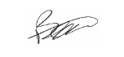

Ben Coxford

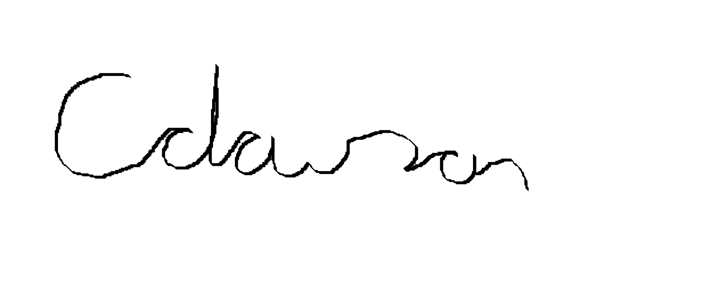

Chris Dawson

Callums Signature